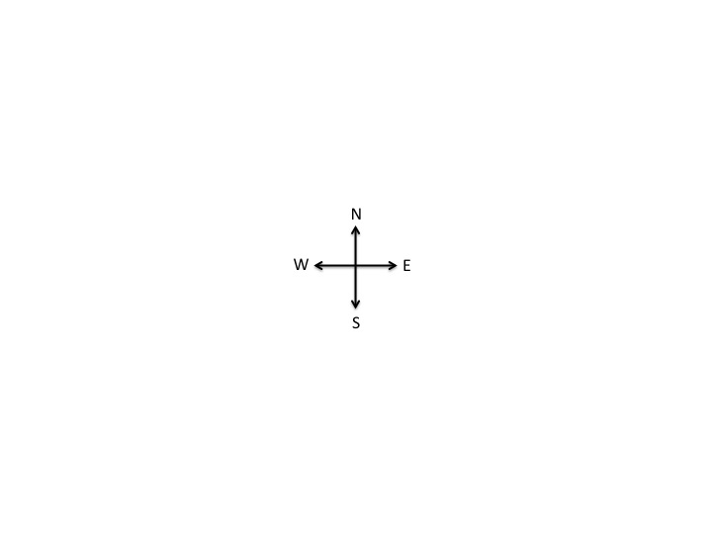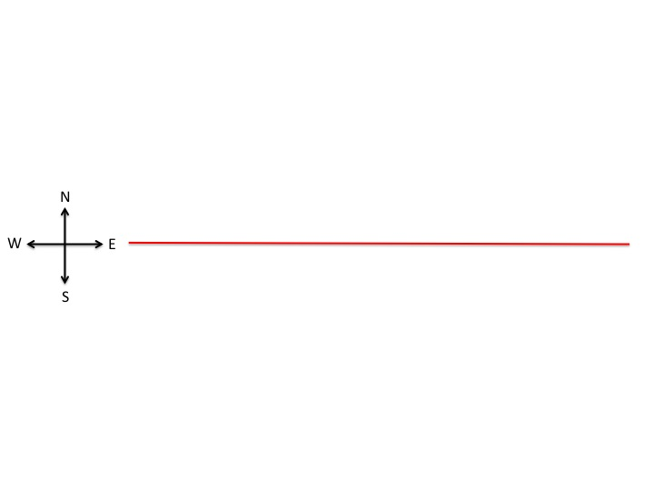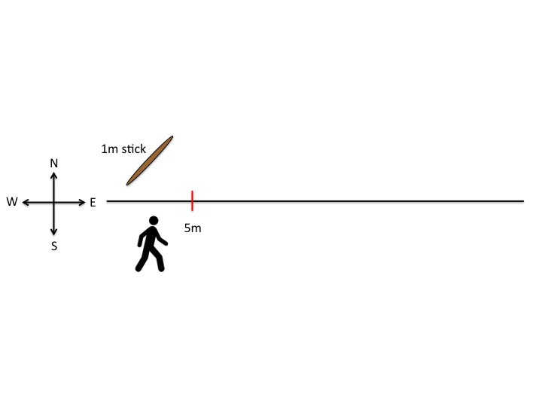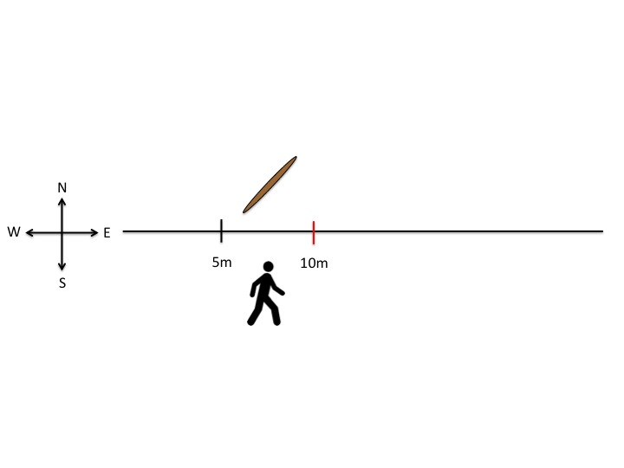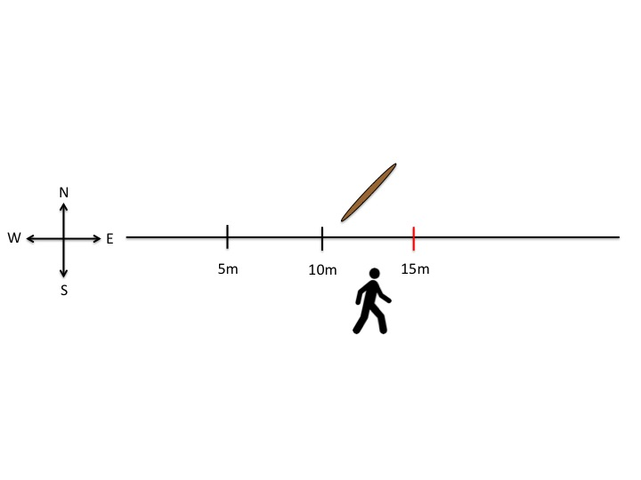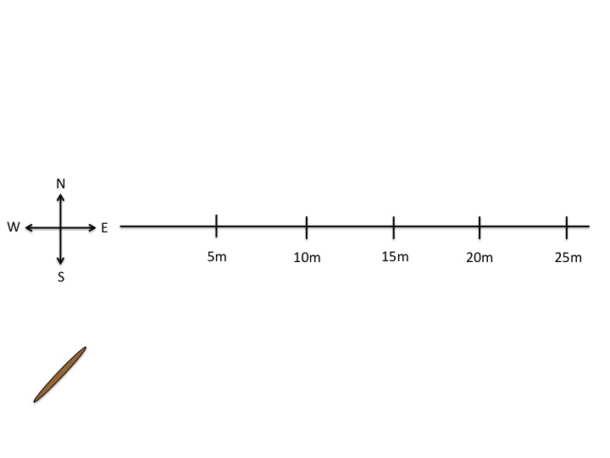

CUT TO: The cross moves to the left on the screen. A line extends from the east side.

Fade in on the cross.

CUT TO: A person holding a stick fades in. The person walks with the stick to the 5 m mark and drops it

After making observations, the user picks up the stick and walks another 5m and drops the stick.

After making observations, the user picks up the stick and walks another 5m meters. This will be shown for 20m and 25m. Each will fade in like the 5m, 10m, and 15m marks.

The last frame will show the completed transect.

Notes:

-We can add a notebook below the walking person to suggest that this is where notes are taken.